1.
#include <stdio.h>

int main() {
int x = 10;

printf("Value of x = %d\n", x);
printf("Virtual address of x = %p\n", (void *)&x);

return 0;
}

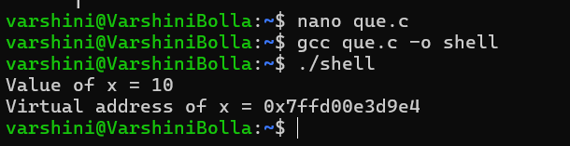

2.

#include <stdio.h>
#include <stdlib.h>

int global = 10;
int bss_variable;

int main() {

int local = 20;

int *heap = malloc(sizeof(int));
*heap = 30;

printf("Code address : %p\n", (void *)main);
printf("Data address : %p\n", (void *)&global);
printf("BSS address : %p\n", (void *)&bss_variable);
printf("Heap address : %p\n", (void *)heap);
printf("Stack address : %p\n", (void *)&local);

free(heap);

return 0;
}

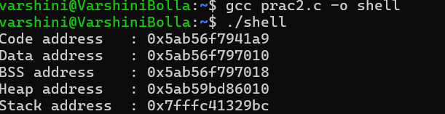

3.
#include <stdio.h>

int main() {

int page_table[4] = {1, -1, 3, -1};

int page;

printf("Enter page number (0-3): ");
scanf("%d", &page);

if (page_table[page] == -1) {
printf("Page Fault!\n");
printf("Page must be loaded into memory.\n");
}
else {
printf("Page is already in memory.\n");
printf("Physical frame = %d\n", page_table[page]);
}

return 0;
}
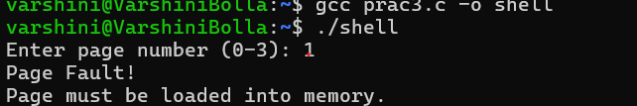

4.
#include <stdio.h>

int main() {

int page_table[] = {3, 5, 1, 7};
int page_size = 100;

int virtual_address = 250;

int page = virtual_address / page_size;
int offset = virtual_address % page_size;

int frame = page_table[page];

int physical_address = frame * page_size + offset;

printf("Virtual Address = %d\n", virtual_address);
printf("Page Number = %d\n", page);
printf("Offset = %d\n", offset);
printf("Frame Number = %d\n", frame);
printf("Physical Address = %d\n", physical_address);

return 0;
}

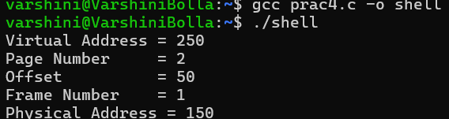
5.
#include <stdio.h>
#include <stdlib.h>
int main() {
int *p;

p = malloc(5 * sizeof(int));

if (p == NULL) {
printf("Memory allocation failed\n");
return 1;
}

for (int i = 0; i < 5; i++) {
p[i] = (i + 1) * 10;
}

for (int i = 0; i < 5; i++) {
printf("%d ", p[i]);
}

printf("\n");

free(p);

return 0;
}
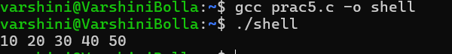

6.
#include <stdio.h>
int main() {
int *p = NULL;
printf("Before accessing memory\n");
*p = 100;
printf("After accessing memory\n");
return 0;
}

